[Search a 2D Matrix](https://leetcode.com/problems/search-a-2d-matrix/description/)

Write an efficient algorithm that searches for a value target in an m x n integer matrix matrix. This matrix has the following properties:

* Integers in each row are sorted from left to right.
* The first integer of each row is greater than the last integer of the previous row.

**Example 1:**

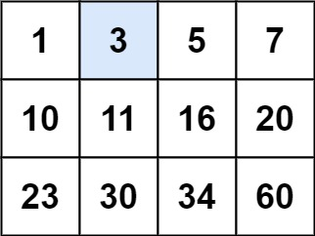

**Input:** matrix = [[1,3,5,7],[10,11,16,20],[23,30,34,60]], target = 3

**Output:** true

**Example 2:**

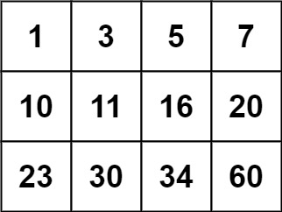

**Input:** matrix = [[1,3,5,7],[10,11,16,20],[23,30,34,60]], target = 13

**Output:** false

**Constraints:**

* m == matrix.length
* n == matrix[i].length
* 1 <= m, n <= 100
* -104 <= matrix[i][j], target <= 104